*This mod must be used with the TerraFirmaCraft mod for Minecraft.*

## Introduction

The idea behind this mod is to allow the player to capture animals in one location and release them to another location.

Animals are easily found but hard to take anywhere. Using rope to lead them works, but is slow and painful and frequently breaks. Also if you pass by a ravine, the animal could fall down and damage/kill itself.

Animal cages of all shapes and descriptions have been used throughout history, but I wanted to implement something that would use a currently unused item in TFC – Burlap Cloth.

The idea of carrying an animal this way was inspired by an Australian folk song “Waltzing Matilda”, where the swagman stuffed the jumbuck (sheep) into his tucker bag in order to steal it.

## Items

1. Standard Tucker Bag – the standard tucker bag is used to capture small animals and release them to another location. This bag has 3 damage points.
2. Reinforced Tucker Bag – the reinforced tucker bag is used to capture large and small animals and release them to another location. This bag has 6 damage points.
3. Iron Buckle – used in the construction of the reinforced tucker bug.

## Recipes

### Standard Tucker Bag

The standard tucker bag is made using two pieces of burlap cloth and four jute fibre, in the crafting space.

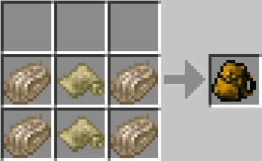

### Standard Tucker Bag (Repair)

The standard tucker bag can be repaired at any stage by using a piece of burlap cloth and one jute fibre.

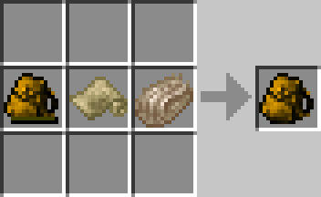

**Note**: If the standard tucker bag is fully damaged, it is destroyed and cannot be repaired.

### Reinforced Tucker Bag

The reinforced tucker bag is made by upgrading an used standard tucker bag with 2 pieces of leather, one iron buckle and any knife.

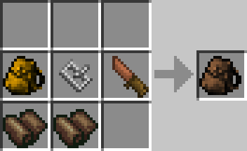

**Note**: If the reinforced tucker bag is fully damaged, it is destroyed and cannot be repaired.

### Reinforced Tucker Bag (Repair)

The reinforced tucker bag can be repaired at any stage by using one piece of burlap cloth, one piece of leather and any knife.

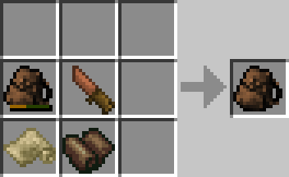

### Iron Buckle

To create the iron buckle using an anvil plan, place one workable wrought iron ingot in the anvil slot and click the plan button. Select the buckle plan from the list.



Then by using the anvil buttons, create the iron buckle. You will get two iron buckles.

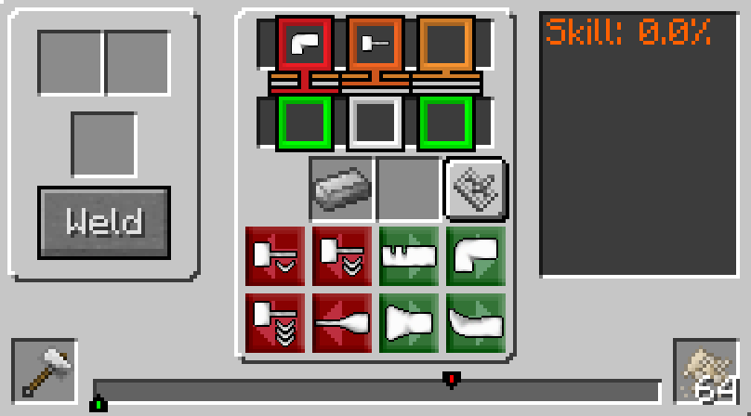

This is the iron buckle after being completed in the anvil.



## Process

### Capturing an Animal

Capturing an animal is as easy as equipping the tucker bag in your hand, walking up to an animal and **left-clicking** the animal. This will remove the animal from the world and place it in the tucker bag.

At this point the tucker bag’s image will change from 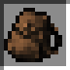 to 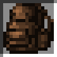, to indicate it is full. Once the tucker bag is full you will also become overburdened and must place the full tucker bag into your back slot to move around.

You will not be able to capture an animal that is currently being ridden, or is leashed.

**Note:** If for any reason you are unable to capture the animal, a chat message will be displayed giving the reason.

### Releasing an Animal

Releasing an animal is as easy as equipping the full tucker bag in your hand and **right-clicking**. This will release the animal from the tucker bag and spawn it into the world. The animal that is spawned into the world will be the same as it went in, all the same information.

**Note:** When releasing the animal, if your crosshairs have something selected, the animal will **not** release. If this happens to you, just move the cross hairs around and keep trying.

When you release an animal from the tucker bag, the tucker bag will take damage. The amount of damage the tucker bag takes is based on the animal and if it is a child or an adult.

When you release the animal the icon will change from  to , to indicate it is empty.

## Additional Information

1. Currently only certain TFC animals can be captured in the tucker bag, these are:
   1. Bears
   2. Chickens
   3. Cows
   4. Deer
   5. Horses (all variants)
   6. Pheasants
   7. Pigs
   8. Sheep
   9. Wolves
2. Config options allow you to turn on/off which animals you want to capture.
3. The tooltip of a full tucker bag shows the type of animal in it.
4. The tooltip of the animal shows which type of bag and the damage inflicted when released.
5. Tucker bags are **not** stackable.
6. Full tucker bags cannot be stored in chests, barrels or vessels.
7. Full tucker bags that are dropped by the player will release the animal into the world.

I have created a list of EntityAnimal objects that can be used by the tucker bag to determine if the animal can be captured. By using the TuckerBagManager, other mods can add their own custom animals to the list so that they can also be captured using the tucker bag.

**Note:** I only allow Entities that extend from the EntityAnimal class to be added to the TuckerBagManager list.

## Animal Details

Listed below are the bag types and damage values for each animal.

|  |  |  |  |  |
| --- | --- | --- | --- | --- |
| **Animal** | **Minimum Adult Bag** | **Adult Damage** | **Minimum Child Bag** | **Child Damage** |
| Bear | Reinforced | 4 | Reinforced | 2 |
| Chicken | Standard | 1 | Standard | 0 |
| Cow | Reinforced | 2 | Standard | 1 |
| Deer | Standard | 2 | Standard | 1 |
| Horse | Reinforced | 3 | Reinforced | 1 |
| Pheasant | Standard | 1 | Standard | 0 |
| Pig | Standard | 2 | Standard | 1 |
| Sheep | Standard | 2 | Standard | 1 |
| Wolf | Reinforced | 3 | Reinforced | 1 |

**Note**: Any animal that can be captured in the Standard tucker bag can also be captured in the reinforced tucker bag.